Call for Papers and Sessions
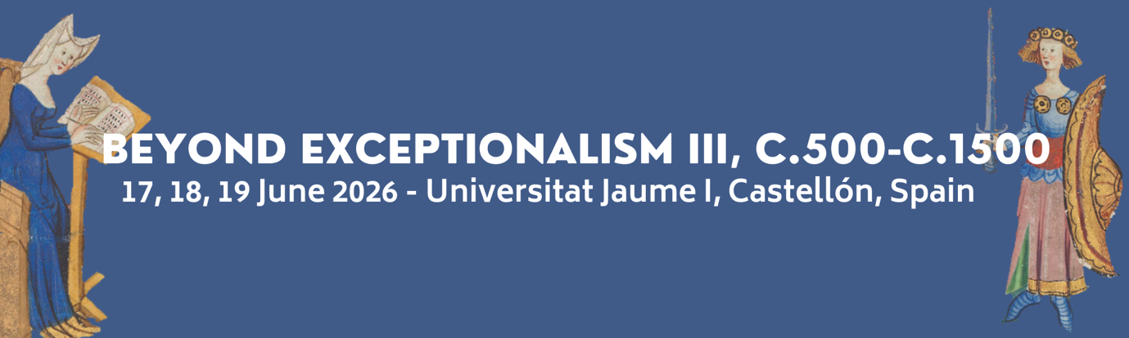
We are delighted to announce the Call for Papers and Sessions for the Beyond Exceptionalism III conference, which will take place on 17–19 June 2026 at the Universitat Jaume I in Castellón, Spain.
Following the success of the previous gatherings in 2015 and 2022, Beyond Exceptionalism III continues to challenge persistent narratives surrounding women’s power and authority in the medieval world. The first Beyond Exceptionalism conference, hosted at The Ohio State University, confronted the enduring notion that women who exercised political or social influence in medieval Europe were mere ‘exceptions’ to a general rule of female passivity. This conversation led to the publication of Medieval Elite Women and the Exercise of Power, 1100–1400: Moving Beyond the Exceptionalist Debate (Palgrave Macmillan, 2019).
The second conference, held in 2022 at the John Rylands Library in Manchester, further expanded this discussion by embracing interdisciplinary and global approaches. Yet, the question remains: how many ‘exceptional’ women does it take before active and influential women become recognised as integral to the fabric of medieval society?
In 2026, Beyond Exceptionalism III aims to continue and broaden this dialogue by examining the exercise of power, authority, and influence by women—elite and non-elite, secular and religious—across Europe and beyond. We welcome contributions that employ diverse methodologies and theoretical frameworks, including gender theory, material culture, network analysis, and spatial approaches, to name but a few. Papers that incorporate comparative or non-European perspectives are especially encouraged.
Abstract deadline is 31 January 2026, to be emailed to beyondexceptionalism@gmail.com.
The conference’s keynotes speakers will be:
- Professor Laura Gathagan, SUNY Cortland
- Dr Natasha Hodgson, Nottingham Trent University
- Dr Patrik Pastrnak, Palacky University Olomouc
- Dr Diana Pelaz Flores, Universidade de Santiago de Compostela

Possible topics include but are not limited to:
- Lordship, queenship, and governance
- Monasticism and lay religious life
- Networks and alliances
- Literacy and patronage
- Law, custom, and power
- Material culture and domestic life
- Medicine, care, and the body
- Warfare, pilgrimage, and mobility

Submission guidelines:
Those wishing to participate should please submit an abstract of maximum 250 words to beyondexceptionalism@gmail.com, as a Microsoft Word or PDF attachment, together with the following personal information:
- Name of presenter(s)
- Participant category (faculty, graduate student, or independent scholar)
- Institutional affiliation
- Email address
- Delivery format (in person or online)
We accept individual submissions for papers, as well as proposals for traditional sessions (3 speakers and a chair). We welcome submissions from scholars at all career stages. The conference will be conducted in a hybrid format, and the deadline for proposals is 31 January 2026. All papers must be delivered in English.

Bursaries:
We are hoping to offer a limited number of bursaries for PhD students and Early Career Researchers presenting at the conference. If you wish to apply for a bursary, please indicate this in your application and include a 200-word statement outlining how participation in the conference will support your academic and professional development.

Please get in touch with us at beyondexceptionalism@gmail.com with any questions you may have.

All the best,
The organising committee
Professor Heather Tanner (Ohio State University)
Professor María Inmaculada Rodríguez Moya (Universitat Jaume I)
Dr Lledó Ruiz Domingo (Universitat Jaume I)
Dr Paula Del Val Vales (independent scholar)

